LGBTQIA+ Needs Assessment Recommendations
2019-2020

INTRODUCTION

In fall 2019, President Richard Helldobler appointed Vice President for Student Development, Miki Cammarata to establish the LGBTQIA+ Needs Assessment Workgroup. The workgroup was charged with identifying the needs and challenges faced by our Lesbian, Gay, Bisexual, Transgender, Queer, Questioning, Intersex, and Allied (LGBTQIA+) identified students at William Paterson University (WPU) and to make recommendations for overcoming roadblocks to student success; student success being defined as retention and graduation.

Specifically, the workgroup sought to:

- Develop a list of quantifiable benchmarks that the university should consider when measuring success with this population.
- Identify strategies the university should consider for tracking students who self-identify as LGBTQIA+.
- Recommend programs or initiatives that the university should consider for improving student success for LGBTQIA+ identified students.
The workgroup represents members of the university community, including staff, faculty and administrators: Yolany Gonell, Director for the Center for Diversity & Inclusion; Steven Marks, Residence Hall Director, Dr. Wendy Christensen, Associate Professor & Assistant Chairperson of Sociology and Criminal Justice; Dr. Zoe Meleo-Erwin, Assistant Professor of Public Health; and Tony Joachim, Librarian.

METHODOLOGY & SUMMARY OF FINDINGS

Benchmark Efforts
The workgroup benchmarked eighteen colleges and universities which included eight (8) aspirational institutions with a Campus Pride Index of 4 points or higher on a 5 point scale; five (5) equivalent regional teaching universities; and four (4) New Jersey competitor institutions. We examined LGBTQIA+ key performance indicators related to program initiatives, LGBTQIA+ Center resources, gender & sexual identity organizations and support structures, and institutional diversity and inclusion efforts. See attached benchmark report.

Focus Group Efforts
In addition to benchmarking efforts, the workgroup conducted four student focus groups, open to all students, regardless of identity. A total of twenty-three (23) students participated. The focus groups were facilitated by two committee members and held at different times and locations during the 2019 – 2020 academic year with the intent to reach a diverse range of students. Three focus groups were advertised broadly on campus across multiple social media platforms, student announcements, printed fliers, select digital monitors, and an email was sent to all students from the Vice President for Student Development. The fourth focus group was by invitation to Dr. Gundling’s Introduction to Transgender Studies course.

Facilitators guided the focus groups with four general prompts, asking students to describe the general campus climate for LGBTQIA+ students at WPU, to identify the needs and concerns of LGBTQIA+ students at WPU, to discuss how WPU could better support LGBTQIA+ students, and to imagine what an ideal LGBTQIA+ friendly campus would look like.

Additionally, a survey was created to capture feedback from commuter students and those unable to participate in an on-campus focus group experience. The online survey was distributed to all students via email. Twenty-one (21) students participated in the online survey.

In summary, a number of students noted they feel comfortable on campus as members of the LGBTQIA+ community. They find acceptance among professors and staff, inclusive assistance at the Counseling Health & Wellness Center, and a variety of LGBTQIA+ focused clubs and events. But, students also noted areas where improvement is needed. Specifically, some students reported experiencing bullying and hate speech on campus, and suggested more LGBTQIA+ focused training for students. Students reported homophobia and transphobia in the classroom. Participants indicated that transgender and gender-nonconforming students experienced microaggressions, were misgendered and outed, and even experienced perceived hostility by professors, RAs, and staff alike. They advocated for diversity training for all faculty and staff, and for more representation of LGBTQIA+ history, issues, and content-specific materials in their classes. Some students noted they had taken 2-3 years of courses at WPU and LGBTQIA+ issues were never mentioned in any of their courses. There was also interest in an LGBTQIA+ minor and expanded course offerings in the area.

Students also noted a need for more gender-inclusive bathrooms, and better advertising for current LGBTQIA+ student services, such as more gender-inclusive housing options. Additionally, students called for more celebrations of diversity (not only LGBTQIA+ students) at WPU. Our students envision a campus where there is an inclusive curriculum, open and affirming faculty, staff, and students, and visible celebrations of campus pride.

CURRENT EFFORTS: WHERE WE ARE NOW

Student Demographics and Data
William Paterson University administered the American College Health Association’s National College Health Assessment (ACHA) in 2015 and 2019. In the spring 2015 semester, a random stratified sample of 4,000 William Paterson University students resulted in a 15.3% (N=612) response rate (Chart 1). Similarly, in spring 2019, a random stratified sample resulted in 13.5% (N=541) response rate (Chart 2). From these two reports we were able to capture sexual orientation data. This data suggests that between 12.3% and 18.3% of our students do not define their sexual identity as heterosexual.

Additionally, in 2017 William Paterson administered the Campus Climate Survey Validation Study (Chart 3) to all degree-seeking undergraduate students 18 years of age or older, yielding an initial population of 8,465 students. Of those, 1,680 students (19.8%) responded. According to this survey 12.9% of William Paterson students do not define their sexuality as heterosexual. While not shown in Chart 3, this survey also indicates that 0.4% of William Paterson students identify as trans individuals.

Chart 1:
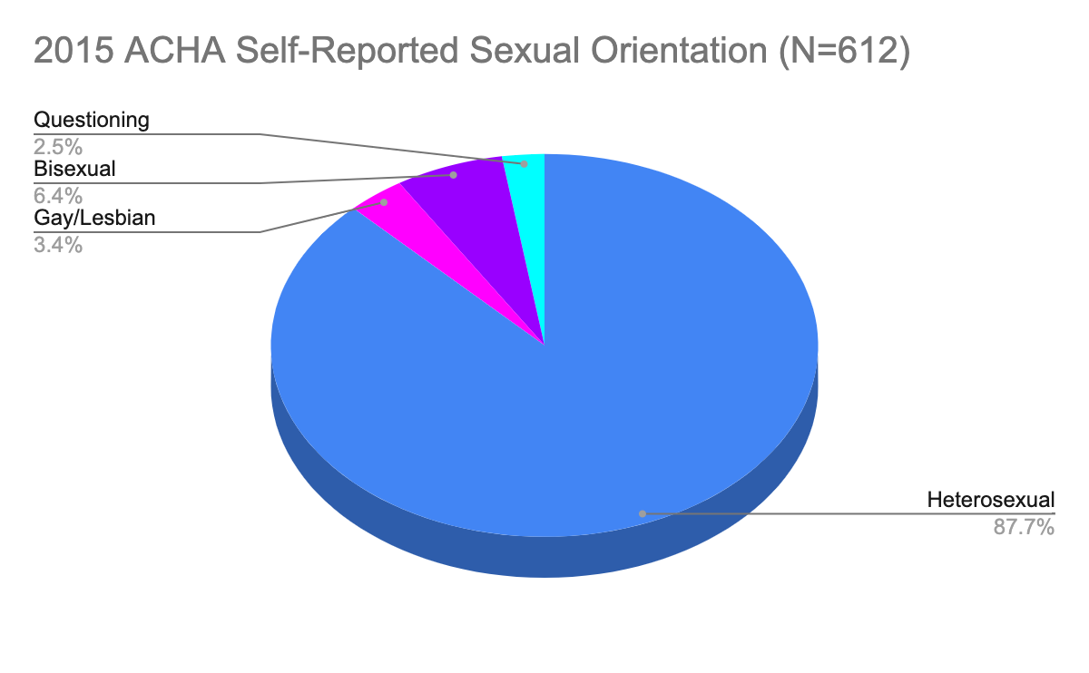

Chart 2:
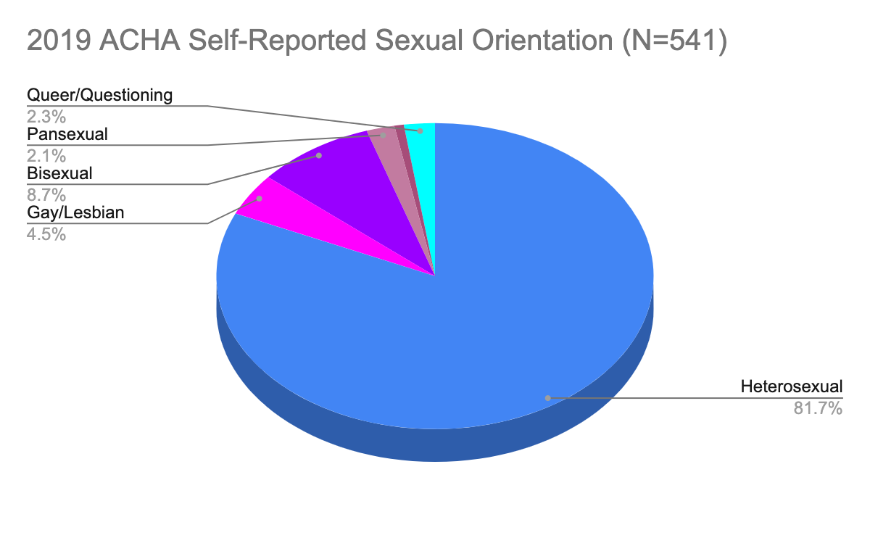

Chart 3:
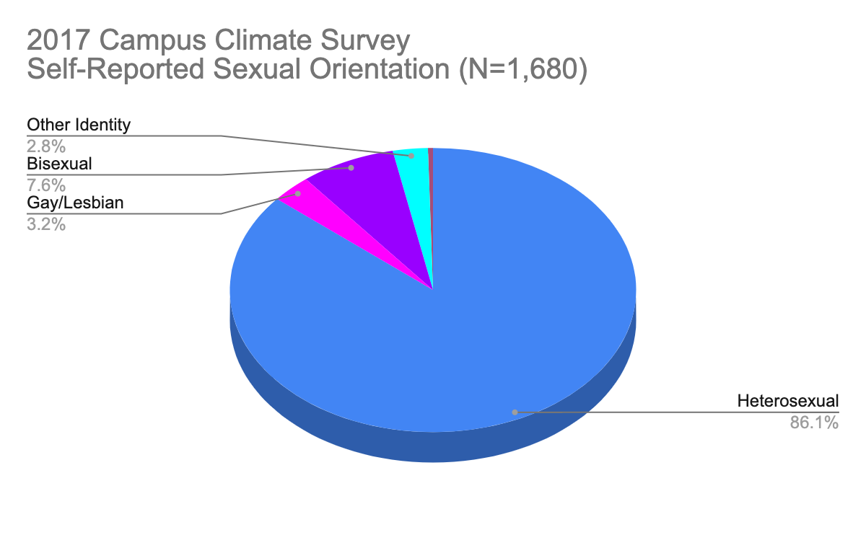

Preferred Name Policy:

Students entering William Paterson University may have gender identities and expressions that differ from the sex recorded on their official documents. Relatedly, such students may identify with a name different from the name given on official records.

William Paterson University has recently changed its policy on affirmed names. Beginning in 2018, students were able to indicate a preferred name on admissions applications. Upon acceptance, the affirmed name is to be displayed across a number of platforms including WPConnect, email display name, Blackboard, the housing management system, Starfish, as well as faculty and advisor listings.

In order to create a welcoming, inclusive, and affirming environment, it is imperative that faculty and staff abide by the affirmed names given on students’ records and respect their gender identities. Failure to do so may create a traumatic, embarrassing, and hurtful environment for students in academic settings, which may, in turn, impede learning as well as retention rates.

Dedicated Staffing Structures:

The Women’s Center
Since 2006, the Women's Center (WC) has provided support to the LGBTQIA+ student club, supported student programs and aided in student leadership development, with its director serving as the club’s advisor until 2016. In 2012, as part of WP Strategic Plan 2012-2022, LGBTQIA+ programs and services became a functional area of The Women's Center and an additional $4,000 in funding was established to better support institutional efforts. Additionally, The Women’s Center provided leadership and coordinated the implementation of the Annual LGBT College Leadership Conference between 2006 and 2018. Once funds provided by the Machuga Foundation for this conference ran out in 2009, The Women’s Center lead effort to form a consortium of regional universities that included (in addition to WPU), Ramapo College, Montclair State University, and New Jersey City University. These institutions took turns annually to host the conference on their campuses and provided support and leadership for the continued implementation of this conference until 2018.

Efforts at providing dedicated staffing to support LGBTQIA+ students included a full time Residence Life Director who worked 10hrs/week at The Women’s Center from 2010 to 2012, providing additional support to programming and club activities for a small stipend paid by the VP of Student Development. This individual created an LGBT Advisory Board that remained active until 2016 co-chaired by the director of the Women’s Center and the Chair of the Women’s and Gender Studies Department. Additionally, in AY 2017-2018, The Women’s Center hired a student worker who served as LGBTQIA+ student ambassador. Among others, this student was instrumental in spearheading policy changes including the WPU policy on affirmed name, supporting the creation of a second LGBTQIA+ student organization for marginalized queer identities, and assisting in developing the LGBT Programs page of the WC website.

In 2018, as part of a U.S. Department of Justice grant for the prevention of gender-based violence, the Women’s Center included a position for a Services Provider to work with LGBTQIA+ victims of sexual assault, domestic violence, dating violence and stalking. However, student engagement beyond the scope of gender-based violence prevention and victim/survivor advocacy by this grant part-time employee is limited.

Since 2018, in anticipation of the hire of the director for the Center for Diversity & Inclusion, support for LGBTQIA+ services and programs out of the Women’s Center has been largely programmatic to include representation at themed heritage celebrations throughout the year, coordination of Safe Zone/LGBTQIA+ Ally training, gender violence prevention, and maintaining the LGBTQIA+ webpage.

The Counseling, Health & Wellness Center
The Counseling, Health & Wellness Center staff works to mitigate barriers for transgender or gender non-conforming students. Some recent efforts to improve these services include:
- A multidisciplinary Transgender/Trans-inclusive Team was assembled in fall 2016 within the department to better evaluate transgender health, health education and mental health practices for this population. During this time, the team evaluated resources in the community, evaluated recommendations from reputable organizations and updated their forms to reflect more transgender friendly language. The team asked for input from the transgender community including some students using Counseling, Health & Wellness Center services.
- The Director and other staff members have attended several workshops hosted by the American College Health Association, and other reputable organizations, on providing health/mental health care to transgender patients and have subsequently shared the knowledge with the remaining clinicians.
- The team identified clinicians that would be the most knowledgeable regarding trans-specific health care and mental health services. As well, they identified a patient advocate, the Charge Nurse, to assist anyone encountering challenges or to report concerns.
General information pertaining to treatment of transgender students:
The World Professional Association for Transgender Health (WPATH) has delineated Standards of Care for the Health of Transsexual, Transgender, and Gender Nonconforming People. The Counseling, Health & Wellness Center staff are familiar with these standards and meet them in many ways.
- With regard to mental health care, the Counseling staff meet the criteria outlined in the Standards of Care regarding competency to work with adults who present with gender dysphoria.
- Our medical staff provide primary health care services and are capable of providing primary care to transgender students.

Campus Climate:

William Paterson University collaborated with the Higher Education Data Sharing Consortium (HEDS) to administer a 6-week HEDS Diversity and Equity Campus Climate Survey, which was started December 9, 2019 and completed February 15, 2020. The survey was administered to 9,787 students, with a 17% student completion. Full survey results expected April 2020. The LGBTQIA+ Needs Assessment workgroup recommends that the university utilize the results of the campus climate to help achieve greater understanding of individual experiences on our campus.

Safe Zone/Ally training for faculty, staff and students:

Historically the Women’s Center has coordinated Safe Zone training for students with off-campus facilitators. Students report a desire for more consistency and expanded topics. In addition, colleges like the College of Humanities and Social Sciences have taken on the task of facilitating Safe Space (101, and a more advanced 201) training for faculty. This training is run voluntarily by faculty members through the Dean’s office, and faculty members who complete the training receive a rainbow Safe Space decal for their office door.

All-Gender Restrooms and Transgender-friendly Locker rooms:

William Paterson University has 36 All-Gender restrooms across campus. An assessment of All-Gender restrooms was facilitated in Spring 2019. Of the 36 All-Gender restrooms, all residence halls have at least one All-Gender restroom; 1 All-Gender restroom at 1600 Valley Road; 1 multi-stall All-Gender restroom in the Student Center; and remaining All-Gender restrooms are located in academic buildings (Ben Shahn, Cheng Library, Hamilton Hall, Hobart Manor, Hunziker Hall, Power Arts, Science Hall East, Shea Center for Performing Arts, Speert Hall, University Hall). A full list of All-Gender restrooms and locations are posted on the Women’s Center resource page: https://www.wpunj.edu/womens-center/lgbtq/lgbtq-resources.html

William Paterson University - New Jersey Athletic Conference has adopted a policy for transgender student-athletes which mirrors the NCAA policy. However, there are no gender neutral locker rooms at any of the Athletic and Recreational Facilities: Fieldhouse, Sports and Recreation Center and Wightman Gym.

The teams that use the locker rooms are listed below:
- Fieldhouse: baseball, field hockey, football, softball and women’s soccer.
- Sports and Recreation Center: volleyball, men’s basketball, women’s basketball and softball (when they practice indoors).
- Wightman Gym: men’s swimming and women’s swimming.
Our men’s soccer team does not have a locker room; they use a changing area located under the bleachers. Our golf and tennis teams do not have a locker room.
Gender Inclusive Housing:
William Paterson University seeks to provide a living environment welcoming to all gender identities; one not limited by the traditional gender binary. Gender Inclusive Housing is available to students of legal age (18 years or older) and allows for same-gender or other-gender identities to live together regardless of assigned gender at birth. This option is available in all residence halls. We currently have 40 students participating in this option.

FUNDAMENTAL RECOMMENDATIONS

The workgroup makes three fundamental recommendations that apply to all ongoing work at William Paterson University regarding Lesbian, Gay, Bisexual, Transgender, Queer, Questioning, Intersex, and Allied (LGBTQIA+) persons and programs on campus.

- LANGUAGE: William Paterson University should use the term “LGBTQIA+” in literature, policies, and organizations moving forward.
LGBTQIA+ (Lesbian, Gay, Bisexual, Transgender, Queer/Questioning, Intersex, Asexual or Allied) is the most inclusive way to refer to the evolving and expanding community. This is common among a variety of higher education organizations and institutions. The “+” is important for capturing the expansiveness of the community and including all dimensions of sexuality, gender identity, experience, and allyship.

- RESPONSIBILITY: The workgroup recommends that ongoing oversight of the implementation of these recommendations should fall jointly to the Provost and the Vice President for Student Development. Both divisions should identify existing administrators who will have ongoing responsibility for monitoring and initiating efforts that impact the LGBTQIA+ community at William Paterson University. Making William Paterson University a more inclusive space for all individuals, and specifically those who identify as LGBTQIA+, involves the entire campus environment, both within and outside the classroom. All members of the WPU community must collaborate in order to effectively implement the recommendations of this report. To assist in institutionalizing these recommendations, the Division of Student Development has already created a new position, the Director of the Center for Diversity & Inclusion. In addition, William Paterson recently appointed a new Chief Diversity Officer.

- INTERSECTIONALITY: The workgroup recommends that all efforts to implement these recommendations consider intersectional axes of oppression. On our diverse campus, sexuality and gender identity are only part of the multiple identities our students have. The concept of intersectionality focuses our attention on how gender and sexuality are interrelated with systems of race, gender, and class oppression. Our students have specific needs based on how their intersectional identities impact their lives. Policies for LGBTQIA+ students must take into account all dimensions of inequality in order to be most effective.

CATEGORICAL RECOMMENDATIONS

The workgroup recommendations below are organized by categories (listed in no particular order):
- LGBTQIA+ Inclusive Policies
- LGBTQIA+ Institutional Commitment
- LGBTQIA+ Student & Campus Life
- LGBTQIA+ Academic Life

- LGBTQIA+ Inclusive Policies
Based on the findings of this needs assessment, the committee recommends:
- Name Policy to include:
  - ID card and email accounts reflective of chosen names.
  - Banner programmed to automatically reflect students’ chosen names and pronouns on class rosters.
  - Website with information about our Preferred Name policy and instructions on how students can change their names and pronouns in university records, documents, and systems.

- LGBTQIA+ Institutional Commitment
Based on the findings of this needs assessment, the committee recommends:
- Mandatory Safe Zone Training for faculty and staff to provide an overview of LGBTQIA+ issues, including classroom inclusion policies and pronoun use.
  - Safe Zone training that is institutionally rebranded. Training should be developed by an advisory board that can create learning outcomes and goals for training modules, develop resource tools, and refine activities.
  - Faculty training to include intersectional LGBTQIA+ themes/ideas/people in curriculum.
- Register William Paterson University with Campus Pride Index. Since 2007, the Campus Pride Index has been the premier LGBTQIA+ national benchmarking tool for colleges and universities. This tool is used by prospective students seeking LGBTQIA+ friendly institutions and those interested in William Paterson University to search a database of LGBTQIA+ friendly institutions.
- Dedicated Staffing Structure
  - Strategic repositioning of LGBTQIA+ services and programs under the Center for Diversity & Inclusion as an affinity-based support service and resource similar to the Black Cultural Center.
  - Strategic funding to create a full time position.
- Re-Establish LGBTQIA+ Advisory Board inclusive of students, faculty, and staff representation to meet quarterly and examine Campus Climate assessment strategies.
3. LGBTQIA+ Student & Campus Life
Based on the findings of this needs assessment, the committee recommends:
- A robust website with comprehensive resources for students. Currently online resources for LGBTQIA+ students are spread across different departments and not user intuitive.
  - A comprehensive website created under the Center for Diversity & inclusion
  - Refining linked pages with LGBTQIA+ specific resources to ensure congruence in branding and messaging (Counseling, Health & Wellness; Women’s Center, etc.).
  - Downloadable guides, booklist, tips and strategies.
  - Dedicated pages for programs such as Safe Zone training and signature events.
  - Establish on-line Safe Zone training and other cultural competencies accessible with WPU credentials.
- Institutionalize Safe Zone/Ally training for students:
  - Require training for all incoming students to include: bystander intervention, intersectional LGBTQIA+ identities, coming out process; allyship, social justice, and current issues.
  - Require advanced training for RAs and other Residential Life staff.
- Living & Learning Communities:
  - Implementation of gender neutral housing assignment as a policy and practice that will benefit all students and as part of new-incoming student room assignment efforts. Considerations and process will need to be examined.
  - Education about the value of Gender-neutral housing in all of the residence halls. To include webpage and promotion.
  - Comprehensive and on-going gender identity training for all Residence Life staff.
- Gender Inclusive Restrooms:
  - Every building on campus must have a gender neutral restroom option.
  - Space challenges in Athletics and Sports Recreation facilities examined with the goal to expand facility locker rooms and single stall bathrooms.
- LGBTQIA+ Events: Implementation of new events to support students and increase visibility on campus, for example:
  - Lavender Graduation Ceremony
  - Transgender Day of Remembrance
  - Gender & Diverse Sexuality Conference/Retreat at William Paterson
  - LGBTQIA+ Support Group

4. LGBTQIA+ Academic Life
Based on the findings of this needs assessment, the committee recommends:
- Re-Establish Gender/Women Studies Department. All benchmark institutions have a Gender/Women’s Studies department. William Paterson should commit to promoting the Gender Women’s Studies Major to students and to re-establishing the department as a center for student and faculty research and learning on LGBTQIA+ issues.
- Expand Course Offerings to include courses on LGBTQIA+ issues in a variety of departments and majors.
- LGBTQIA+ Curriculum Inclusion:
  - Review current curriculum to ensure that intersectional LGBTQIA+ issues are a part of all UCC Area 4 (Diversity and Justice) courses.
  - Encourage faculty to include intersectional LGBTQIA+ issues in a variety of courses.
- LGBTQIA+ Minor: Create an interdisciplinary LGBTQIA+ minor program for students who are interested in rounding out their major.

