Workshop: Creating Multi-Draft Assignments for English 1500

Chris’s Writing Project on Vampires

Two of the writing projects that we do in my English 1500 class go through seven stages of revision. Below, I show you one of those projects. First I give a brief description of the different phases. Each phase has a link, and if you click on it, you’ll be taken to a fuller description of that phase along with student examples, feedback from me, and some of my notes about that particular phase of the process.

We do four different projects over the semester, but students choose which two to develop into full-blown revised drafts. Those two will be included in the final portfolio due on the last day of the semester. The other two projects stop after “Phase Two.”

Notes: For people who prefer not to use portfolio grading, the sequence could probably be compressed so that one revised project is due around mid-semester and the other is due at the end of the semester.

Click on the link below for a the description of the writing project that I give to students when we begin:

Writing Project on Vampires

Thumbnail Sketch of Phases

Phase One – Discussion Board Posts: Two posts (one before each class) made to the Discussion Board for homework. Each time, students come to class, share their homework in small groups, and report back to the class about what was said in their group. We then discuss the question and their responses as a class.

My Feedback: I give brief feedback to a few representative posts to show what I’m looking for.

Phase Two – Developmental Draft Based on DB Posts: The following week, students draw from their two DB posts to create a 3 page draft. I emphasize that this is only a rough draft and that if they choose to revise it for their final portfolio, it will need to be longer and more developed. They submit this draft to me for feedback.

My Feedback: A couple of paragraphs focused on what I like and how they might develop this draft.

Phase Three—Peer Feedback in Small Groups, With Discussion and Me Sharing Some Comments in Class: It’s two weeks later, and we have moved on to other readings. But they’re still working on these writing projects. I ask them to choose one and develop it into a 5-6 page paper. I assign online writing groups and have them post their drafts and then give feedback for homework. Then they spend part of a class discussing the feedback in their group.
My Feedback: I go into the groups and read everyone’s draft and the feedback they get, but I don’t write comments on most of it. Instead, I pick out examples of feedback to discuss in class after they’re done sharing in groups.

Phase Four—Revised Drafts Submitted to Me: About a third of the way through the semester, I ask students to select one of their writing projects to submit to me for written feedback.

My Feedback: This is the first time I really give more extensive feedback—which I only do for two of the four writing projects. While I don’t give a grade, I do sort it into one of three categories according to how close I think it is to being finished. While the feedback at this point is a bit more critical, it’s still mostly focused on how to develop the paper further.

Phase Five-Conferences: About two to three weeks before the end of the semester, I conference with students about the two projects they’re planning to include in their final portfolio. At this point, I can check in with them about whether they have questions about my feedback or what they need to do to revise.

My Feedback: I don’t give written feedback at this point, but students take notes, and after the conference, they write a revision plan.

Phase Six—Proofreading Workshops: In the final weeks of the semester, we hold proofreading/copy-editing workshops in class.

Phase Seven—Final Portfolio: They submit their final portfolio, choosing two of the four writing projects that they’ve worked on over the semester. The portfolio includes a cover letter, explaining revisions to the papers, final drafts, and rough work, including feedback. Both writing projects must demonstrate extensive revision.

My Feedback: Minimal feedback from me—a sentence or two for the entire portfolio. Maybe slightly more if the portfolio is failing or receiving a very low grade.

More Extensive Description with Examples

Phase One – Posts to the Discussion Board:

- Description
- Sample Student Responses with My Feedback
- My Notes

Description: I give students a discussion question and they post a 300 word response to the Discussion Board in Blackboard. For the first ten minutes of the next class, they access their posts and share them in small groups. Someone from each group reports to the class, and then we have a class discussion. Before class, I look over the posts and pick out a few to comment on as part of our class discussion. I then repeat this process the next class with a second discussion question.

Discussion Questions and Sample Student Responses with My Feedback:

Post A: Look in the Course Materials section and click on the "Images" folder. Click on "Images of Vampires." Then answer the following question:
This document shows images of vampires from movies, movie posters, and television from the sixties to the present day. I'm going to ask you to look at these images and to analyze them. What seems to have changed over the decades? What seems to have stayed the same? Try to look as closely at the images as you can--analyzing specific elements of them and discussing what you notice about them.
Post at least 300 words in response to this question in the new forum on the Discussion Board. Your post must be made no later than 9:00 A.M. on Thursday.

Sample Responses:

Liz: The photo from 1970 is a great example. While Dracula looks intimidating and quite menacing, the woman in the bed is looking at him with big and wishful eyes. Her body language and and facial expressions look less scared or nervous and more hopeful or sensual. Dracula himself is a slicked back, good looking guy and looks more like a figure of sexual desire than a vampire who is about to bite her neck.

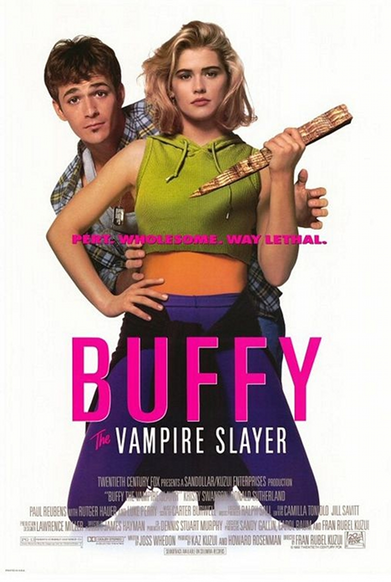 | Taylor: All of the victims from the photos until the year 1992 are women who are flirty and in the vampires and society’s eye are easy targets. But we then see a shift of the women also becoming not only vampires, but also the people who destroy vampires (specifically talking about Buffy the Vampire Slayer).  Prof W: Excellent—but please be more specific when you analyze the image here. Note the tag line: “Pert. Wholesome. Way Lethal.”

Post B: Read the first four chapters of Bram Stoker’s Dracula. Then do the following writing assignment:

If horror is about what people fear and desire, then what is it that Jonathan Harker seems to fear and desire? Quote from the novel to support your answer. How do you think that Victorian English readers would have reacted to this novel?

Your response must be at least 300 words long, and it must be posted to the new forum in the Discussion Board by 9:00 A.M. on Tuesday. Late or short posts will not receive credit.

Sample Responses:

Vinny: I think to Victoria England readers this book probably reinforced any negative stereotypes they had against eastern Europe being filled with monsters and superstition. When Harker is about to depart to visit the Count the innkeeper tells him “It is the eve of St. George’s Day. Do you not know that to-night, when the clock strikes midnight, all the evil things in the world will have full sway? Do you know where you are going, and what you are going to?” this is showing how the locals fear these superstitions and he shrugs her concern off which represents how the English at the time treated eastern Europe as a lesser class and they believe in silly superstitions that they believed they were too smart to fall for.

Prof W: He’s pleasant to the locals but also condescending, as though he considers himself superior because he’s from rational London and doesn’t have these superstitions. Of course, those superstitions turn out to be true. His rationality turns out to be a weakness.

Matt: He mentions that he is engaged, yet when approached in the night by three female vampires, he mentions how “voluptuous” they are and how much they both entice, and strike fear in to him. He is utterly fascinated with these women, yet he has an absolute fear of them at the same time, not in a sense of danger because if it was, he would turn and try to escape. I think he was afraid of enjoying himself with the women knowing that he had his fiancé to think about back home. “The fair girl . . . bent over me till I could feel the movement of her breath upon me. . . . The girl went on her knees, and bent over me, simply gloating. There was a deliberate voluptuousness which was both thrilling and repulsive, and as she arched her neck she actually licked her lips like an animal. . .”. This clearly was not a fearful aversion in my eyes.

Prof W: Now think back to yesterday’s discussion on the vampire images and how vampires seem to represent sex. Think about how the women in many of those images seemed to be waiting for the vampire rather than running from him.

Notes: One of the things I want to emphasize to students through this process is that writing leads to discussion which then leads to more writing. Writing is a way to figure things out; not just a way to record things you already know.

Phase Two – Developmental Draft Based on DB Posts:
- Description
- Sample of My Feedback
- My Notes

Description: I tell students the following: Expand on both of the posts that you made to the Discussion Board and create a draft of an essay that fulfills the requirements of Writing Project #2 (see assignment directions attached). Your draft should be at least 900 words. Please note that this is not the finished version of your essay. You will be developing it and expanding on it later in the semester. It’s just a chance for you to get started and to get some feedback. Note: You can copy and paste parts of your DB posts, but you need to rewrite this draft so that it feels more like an essay. Don’t just copy and paste the posts and then add to them.

Sample Feedback to Draft:

Fiona,

I love what you say about women being the victims in early vampire movies but not in more recent versions like Buffy The Vampire Slayer or True Blood. (By the way, you should italicize titles of novels, movies, or television series.) If you revise this, I would like to hear more details about those examples. Who are the female characters, and how are they portrayed?

You mention the vampire women in Dracula, but you don’t quote from that novel and you don’t say much about why that scene with Jonathan is important, so that’s also something I’ll want you to expand on in the next draft. How can you connect that idea to those other vampire stories?

Notes: I don’t waste my time pointing out errors or trying to fix things at this point—though I did make that comment about titles. I don’t worry about loose ends or tangents. I don’t comment in the margins of their papers, just at the end. At this stage of the writing process, I don’t want them to think that revising means fixing things that are wrong—which is what they usually think. I want them to think of revising as developing things that are right.

Phase Three—Peer Feedback in Small Groups, With Discussion and Me Sharing Some Comments in Class:

- Description
- Sample of Student’s Feedback with My Comments
- My Notes

Description: This phase happens about two weeks later. At this point, we have moved on to other readings. But students have already been working on two writing projects, including this one. I ask them to choose one of those projects and develop it to a 5-6 page paper. I organize them into writing groups of three or four where they post the draft and give each other feedback. In the example below, I’ve asked them to give feedback by doing two things: Identifying a possible thesis and addressing whether the draft is summarizing the readings or analyzing them. Both of these are tricky concepts, and we spend some class time discussing them.

They post their feedback ahead of time so that I can see it. Then they come to class, access the feedback online, and discuss it in their groups. I come around and check in on them.

Depending on how this part goes, I either save the second half of the class for discussion of the process, or I save it for the following class. Since I can access all of the groups and their feedback, I take some examples and project them onto the screen in the class so that I can talk about what I mean by the terms “thesis” and “analysis.”

Amy’s Feedback to David’s Paper:

Hey! I thought this was a good first draft! I couldn't completely identify the thesis though. When reading maybe you can try using a thesis that clearly identifies that there is a difference from old vampires vs the new ones. If a sentence like that was added into the end of the first paragraph it would be a great rough draft. I like that you emphasized the desires of modern vampire movies and stories. It is good that you were able to compare the desires of the Victorian era to modern day desires that many have experienced. I think that you should focus a bit more on what the audience desires about vampire films and what people as a whole desire more than the story line of each of the works. In addition, when you say, "For example when a teenage girl get there first boyfriend they are madly in love with them sex isn't the only thing that there are attached to it can be the looks, the love etc," I like the emphasis on romance and teenage love; however, I do believe sex has everything to do with it. The reason Bella and Edward are attractive young adults and are so strongly attracted to each other is due to the sex appeal of the movie. Therefore, in a way the lust and teenage romance has everything to do with sex. This is a very good beginning to an essay though. It is so good that you don't summarize the books much and you more so analyze the plots of both Dracula and Twilight. Other than working on those few things, I do not believe there is much other than sentence structure and grammar wrong with it. But that can be mended when revising and organizing you final draft. Good job!

My Comments:

Thesis: "I couldn't completely identify the thesis though. When reading maybe you can try using a thesis that clearly identifies that there is a difference from old vampires vs the new ones."
Great! This is what you're supposed to be doing--helping each other move towards a thesis if you don't have one yet. So one possibility is to build the paper around a contrast between old vampire stories and modern ones. Can you be more specific about this, though? What is in the paper that could contribute towards this contrast? What is the difference between the old stories and the new ones? What else in the draft could build towards that?
Summary vs. Analysis: " It is good that you were able to compare the desires of the Victorian era to modern day desires that many have experienced."

Good, but be more specific. What were those desires? What comparison does the draft make?
" . . .you don't summarize the books much and you more so analyze the plots of both Dracula and Twilight."

Be more specific. What does the draft analyze about these books?

Notes: Peer feedback is always tricky, and some students do it better than others. Research shows that students actually get more out of giving feedback than they do out of receiving it. I’ve experimented with different directions for giving feedback, but I think it’s the process of having to share their drafts and talk about them that is important rather than the specific feedback that they get.

What I’m trying to do here is get them to talk about “thesis” and “analysis,” two concepts that most students struggle with. Students get a chance to share their writing with each other here, but I try to use my “intervention” as a way to add on to that discussion and clarify what I mean by those concepts. I don’t comment on the drafts themselves, but I try to push the discussion along so that they are thinking about them as they revise.

Phase Four—Revised Drafts Submitted to Me:

- Description
- Sample of My Feedback to Draft
- My Notes

Description: I ask students to select one of their two writing projects to submit to me for written feedback. They must attach rough work, and at this point, I’m insisting on significant revision. I give them written feedback.

I don’t give grades, since I only grade their final portfolio, but I do give them a “status update,” sorting their paper into one of three categories: “Portfolio-Ready” (It would get at least a B if submitted with no further revision), “In-Progress” (It needs further revision before it would get a B), or “Resubmit” (Something was not done correctly, and it won’t get credit unless it’s resubmitted). My feedback at this point is a little more critical. I may include marginal comments—though I always wonder if maybe I shouldn’t. But it’s still oriented towards revision.

Sample Feedback to Draft:

On page two, you say: “The female victim was often sexualized in the movies and on movie posters.” Great—but you need to give specific examples. If you want, you can include images directly in your paper.

When you say “There wasn’t a lot of romance between the victim and the vampire,” what do you mean? Again—can you give a specific example? When you say that early vampires “were seen as heartless monsters,” can you give an example—a quote? Dialogue? A scene?

I love the line, “Movies and novels began to target teenage girls because they are the most interested in the mysterious relationship between a ‘monster’ and a girl.” You then give Twilight as an example. You say that Bella likes Edward because he is odd. That’s excellent, but can you expand on this? Quote the novel or the movie. Go into more detail here.

Status of Paper at This Point: In-Progress. I think this is a great mid-draft. You need to develop it more with more specific examples, but I really like where you are going with it!

Notes: At this point, some teachers might want to give them a grade. I generally find that papers still aren’t ready for grades at this point. Most of them need more work—usually developing the ideas and sometimes finding a specific thesis. And if I gave a grade, I feel like I’d put all of my energy into justifying the grade (which is not fun) instead of encouraging revision.

Phase Five-Conferences:

- Description
- My Notes

Description: We’re now within two to three weeks of the end of the semester, and they are deciding which drafts to submit to the final portfolio and what further revision is needed. I cancel class for a week or a week and a half and schedule conferences. Students bring in the drafts they think are going into the final portfolio. They also bring in any feedback they have gotten on the drafts. I don’t read anything in preparation for this conference, but I talk with them about what feedback they’ve gotten so far, if they understand it, and what their plans are for revision. Their homework assignment following our conference is to make a revision plan, including possible plans to take their papers to the Writing Center and what they will work on if they do.

My Notes: At this point, the better students will know what they need to do, and this is mostly a check-in to reassure them and encourage them. The weaker students may not have done much revision at all. They may not have read my comments with much thought, or maybe they read them but never went back and revised the draft. Because I don’t grade drafts, some students may think that they don’t have to do much to revise. This is a chance for me to emphasize how much work there is left to be done. If students are nervous about grades, I may say something like, “Well, if you turned this in now, you’d probably get a low C or maybe even a D. But you’d be crazy to do that when it still needs more work. Let’s talk about what you need to do to revise it.”

Phase Six—Proofreading Workshops:

- Description
- My Notes

Description: The last week of class, students bring in finished or nearly finished drafts, and we spend class reading them and working on things like punctuation and how to use quotations.
Notes: I’m still not sure if I’m devoting enough time to the “nuts and bolts” of copy-editing, but it feels to me like there are so many larger issues to cover, that this gets a little short shrift. I’m still struggling with that. But I know that once we start dealing with proofreading, they think they’re done revising, so I leave this part until last. I want to emphasize that what they’ve done up to now is revising and that copy-editing is a different thing.

Phase Seven—Final Portfolio:

- Description
- My Notes

Description: Students submit their final portfolio, which includes two extensively revised papers and a cover letter discussing what changes they’ve made between the drafts. They must also include the revision plan that they made after our conference, and they must attach all rough work to the back of each draft—including any feedback from me and other students.

The portfolio is due on the final day of class. I have a checklist for everything that must be in it, and we spend ten minutes at the beginning of the last class going over it. Invariably, a few students don’t have everything that they’re supposed to, and they have to get it to me later in the day.
Notes: I don’t spend much time on the final portfolios. At this point, I should be pretty familiar with the papers. I look over my past written feedback and read the papers to see how they’ve been revised. I can quickly put a grade on the portfolio with only a sentence or two of feedback. I only include more feedback if I’m failing a student or giving a low grade, but even then, it’s probably not more than a paragraph. Students just don’t care about the feedback at this point, and I’d rather spend my time and energy giving it earlier in the semester when it can do some good.

Below is the description of the writing project that I give students when we begin the entire project. I post descriptions of all four writing projects in a folder on Blackboard and remind students periodically to refer to them.

Writing Project: Vampires (or another title if you can come up with a better one!)

Paper Topic: You’ve read the first four chapters of Dracula, but my guess is that you’ve read some other vampire stories or at least seen vampires in movies or television. You might even have tasted Count Chocula cereal—though you may be too young for that. And you’ve also looked at images of vampires for your Discussion Board assignment. So now I’d like you to write about vampires. Why are they such an enduring monster in literature as well as in popular culture? What is our attraction to them? Why do we keep coming back to the vampire story?

You should quote from some part of Dracula, but you should also give a specific example of at least one other version of a vampire in fiction, film, or popular culture—either another version of Count Dracula or of a different vampire. When you discuss what’s interesting about these vampires or their stories, be as specific as you can be. If you can quote from other stories or movies, do so. If you can refer to specific images or scenes, do so.

Rough Draft: All of our writing projects begin with a rough draft. You should write at least three pages (900 words) as a way of beginning to think about your topic. This draft is due on Thursday, February 7. It can be very rough writing. It won’t be graded or even handed in to me, but it will be shared in your writing circle. It’s a first step towards developing it into a longer, more finished paper. If fact, it may be your only step. If you don’t want to continue to work on it, you can move on to other projects.

Developed Draft: You will have a developed draft due on Thursday, February 21. That is, you will need to choose a paper that to submit to me for feedback. That could be this one, or it could be your first writing project. In either case, I will expect you to revise your previous draft in response to the feedback you got in your group and to develop it to 5-6 pages (1,500-1,800 words) in length.

